Mini-Project Report on

**Calorie Tracker Web Application Using Python**

Submitted in partial fulfillment of the requirements for the degree of

BACHELOR OF ENGINEERING

IN

### Computer Science & Engineering

### Artificial Intelligence & Machine Learning

### By

### Chavez Anthony (22106038)

Sumeet Gupta (22106071)

Mohammed Ali Bardi (22106038)

Kshitij Chitnis (22106078)

 Under the guidance of

## Prof. Shraddha Dalvi

### Department of Computer Science & Engineering

### (Artificial Intelligence & Machine Learning)

**A. P. Shah Institute of Technology**

**G. B. Road, Kasarvadavali, Thane (W)-400615**

**University Of Mumbai**

**2023-2024**



## A. P. SHAH INSTITUTE OF TECHNOLOGY

## 

## CERTIFICATE

This is to certify that the project entitled “**Stocks Price Predictor using machine learning”** is a bonafide work of Chavez Anthony (22106038), Sumeet Gupta (22106071), Mohammed Ali Bardi (22106058), Kshitij Chitnis (22106078) submitted to the University of Mumbai in partial fulfillment of the requirement for the award of **Bachelor of Engineering** in **Computer Science & Engineering (Artificial Intelligence & Machine Learning).**

|  |  |
| --- | --- |
| ________________ | _______________ |
| Prof. Shraddha Dalvi | Dr. Jaya Gupta |
| Mini Project Guide | Head of Department |

## 

## A. P. SHAH INSTITUTE OF TECHNOLOGY

## Project Report Approval

This Mini project report entitled “**Calorie Tracker Web Application Using Python*”*** by **Chavez Anthony, Sumeet Gupta, Mohammed Ali Bardi and Kshitij Chitnis** is approved for the degree of ***Bachelor of Engineering*** in ***Computer Science &Engineering***, (AI&ML) ***2023-24***.

##### External Examiner:

##### Internal Examiner:

Place: APSIT, Thane

Date:

**Declaration**

##### We declare that this written submission represents my ideas in my own words and where others' ideas or words have been included, I have adequately cited and referenced the original sources. I also declare that I have adhered to all principles of academic honesty and integrity and have not misrepresented or fabricated or falsified any idea/data/fact/source in my submission. I understand that any violation of the above will be cause for disciplinary action by the Institute and can also evoke penal action from the sources which have thus not been properly cited or from whom proper permission has not been taken when needed.

|  |  |  |  |
| --- | --- | --- | --- |
| Chavez Anthony | Sumeet Gupta | M. Ali Bardi | Kshitij Chitnis |
| (22106038) | (22106071) | (22106058) | (22106078) |

#### ABSTRACT

In the digital age, where accessibility and convenience are paramount, web-based applications have become integral tools for managing various aspects of daily life. In this context, we propose the development of a web-based calorie tracker application using Python, which will provide users with a seamless experience for monitoring their dietary intake and achieving their health goals.

The implementation of the web-based calorie tracker will utilize Python's versatile web development frameworks, such as Django or Flask, along with HTML, CSS, and JavaScript for frontend design and interactivity. By harnessing the power of web technologies and Python's flexibility, this project aims to deliver a comprehensive and user-friendly solution for effective calorie tracking and promoting healthier lifestyles.

**Index**

|  |  |  |  |
| --- | --- | --- | --- |
| Index | | | Page no. |
| Chapter-1 | | | 1 |
|  | Introduction | |  |
|  |  |  |  |
| Chapter-2 | | | 4 |
|  | Literature Survey | |  |
|  | 2.1 | History |  |
|  | 2.1 | Review |  |
|  |  |  |  |
| Chapter-3 | | | 5 |
|  | Problem Statement | |  |
|  |  |  |  |
| Chapter-4 | | | 6 |
|  | Experimental Setup | |  |
|  | 4.1 | Hardware setup |  |
|  | 4.2 | Software Setup |  |
|  |  |  |  |
| Chapter-5 | | | 10 |
|  | Proposed system and Implementation | |  |
|  | 5.1 | Block Diagram of proposed system |  |
|  | 5.2 | Description of Block diagram |  |
|  | 5.3 | Implementation |  |
|  |  |  |  |
| Chapter-6 | | | 13 |
|  | Conclusion | |  |
|  |  |  |  |
| References | | | 14 |
|  |  |  |  |

**CHAPTER 1**

**INTRODUCTION**

### INTRODUCTION

In the digital era, where technology intertwines with every facet of our lives, health and fitness management are no exceptions. With an increasing emphasis on well-being and nutrition, individuals are seeking efficient and accessible tools to monitor their dietary habits. In response to this need, this project introduces the development of a web-based calorie tracker using Python, aiming to provide users with a convenient and effective means of managing their daily calorie intake.

The primary objective of this web-based calorie tracker is to empower users in making informed decisions about their dietary choices. By providing a user-friendly interface and real-time feedback on calorie consumption, the application aims to promote healthier eating habits and facilitate the achievement of nutritional goals. Through features such as meal logging, goal setting, and progress tracking, users will gain insights into their dietary patterns and receive personalized recommendations for improving their overall well-being.

The implementation of this project will rely on Python's robust web development frameworks, such as Django or Flask, to build the backend infrastructure of the calorie tracker application. Additionally, HTML, CSS, and JavaScript will be utilized for frontend design and interactivity, ensuring a seamless and engaging user experience. Integration with a comprehensive food database will enable users to easily search for and log their meals, while advanced functionalities such as data visualization will provide users with insights into their dietary trends and progress over time.

# CHAPTER 2 LITERATURE SURVEY

#### 1. LITERATURE SURVEY

**2.1 History**

The history of calorie tracking can be traced back to the late 19th century when scientists began to explore the concept of measuring energy intake and expenditure in relation to human health. The notion of a "calorie" itself originates from the work of French chemist Nicolas Clément, who introduced the term in 1824 to describe the energy required to raise the temperature of one kilogram of water by one degree Celsius.

The early 20th century saw significant advancements in understanding the role of calories in human nutrition. Wilbur Atwater, an American chemist, conducted pioneering research on the energy content of foods and developed the Atwater system for calculating the caloric value of different macronutrients. His work laid the foundation for modern methods of estimating calorie intake.

In the mid-20th century, as interest in nutrition and weight management grew, calorie counting became a common practice among individuals seeking to control their dietary intake. Calorie counting initially relied on manual calculations using food labels, reference tables, and handwritten logs. However, with the advent of electronic calculators and personal computers in the latter half of the century, tracking calories became more accessible and convenient.

The emergence of digital technology in the late 20th and early 21st centuries revolutionized the way people track their calorie intake. The proliferation of mobile devices and internet connectivity led to the development of various digital tools and applications for calorie tracking. Early examples included desktop software and online calorie databases that allowed users to log their meals and track their nutritional intake.

With the rise of smartphones and mobile apps, calorie tracking became even more widespread and user-friendly. Companies and developers began creating dedicated calorie tracker apps that offered features such as barcode scanning, food databases, meal logging, and real-time nutritional analysis. These apps provided users with personalized recommendations, goal setting functionalities, and social sharing capabilities, enhancing the overall user experience and effectiveness of calorie tracking.

Today, calorie tracking continues to evolve with advancements in technology and data science. Modern calorie tracker apps leverage machine learning algorithms, artificial intelligence, and wearable devices to provide users with more accurate and personalized insights into their dietary habits and health outcomes. Integration with smart scales, fitness trackers, and health platforms further enhances the utility and interoperability of calorie tracking tools, empowering individuals to make informed decisions about their nutrition and well-being.

**2.2 Literature Review**

1.Issues in dietary intake assessment of children and adolescents:

There has been a number of proposed methods for measuring daily food diet information. In this, one existing system which asks the user to give the details of food and drinks he/she had consumed in 24 hours to the instructor or dietitian but the problem with this type of method is sometimes people won’t be able to remember exactly what they ate with content and amount. It is hard for the user to explain and give details of everything he/she consumed in the last 24-Hours

2. Determination of food portion size by image processing:

Researchers trying to improve on this technique and in the paper [2] author uses a new idea in which the user takes a picture of the food before eating and using a calorie card as a reference, it tells the calorie value of the food. The card should be placed next to the food while capturing the picture. Drawback of this system is that it will not work without the card. There is another system which is based on support vector machine but use the thumb for calibration of each and every food image, it requires long calculation for measuring nutrition of the food photo taken with the camera of a mobile phone, but the use of thumb of patient for calibration, solves the problem of carrying cards or special trays. More specifically, a thumb image is captured and stored with its measurements in the first usage time (first time calibration).

3. Self-monitoring dietary intake: Current and future practices:

In this, another method had been proposed by the author where a user have the

5

PDA (personal diet assistant) app. In which the user records the daily food intake information on a mobile phone. but it has been shown that result of the portion has significant error and take long time

for the user to enter the record.

# 

# CHAPTER 3

# Problem Statement

#### Problem Statement

Despite the growing awareness of the importance of healthy eating habits, many individuals struggle to effectively monitor their daily calorie intake. Traditional methods of calorie tracking, such as manual record-keeping or using standalone applications, often lack convenience, accessibility, and personalized insights. Moreover, existing web-based calorie tracking solutions may be either too complex for casual users or too simplistic to provide meaningful feedback.

Therefore, the problem this project aims to address is the lack of a comprehensive, user-friendly, and accessible web-based calorie tracker that leverages the capabilities of Python to provide individuals with an intuitive tool for managing their nutritional intake. This calorie tracker should overcome the limitations of existing solutions by offering features such as seamless integration with a comprehensive food database, real-time calorie calculation, personalized goal setting, progress tracking, and intuitive data visualization.

# CHAPTER 4

**Experimental Setup**

##### EXPERIMENTAL SETUP

###### Hardware Setup

1. CPU: core i5 or higher version
2. RAM: recommended 4GB and More
3. STORAGE: 256GB Disk Space or More
4. OS: Microsoft Windows 7, Microsoft Windows 8, Microsoft Windows 10 or late**r**

###### Software Setup

1. **Python virtual environment using Django**
2. **Postgresql database**

# 

# CHAPTER 5

**Proposed System & Implementation**

###### Block Diagram of Proposed System

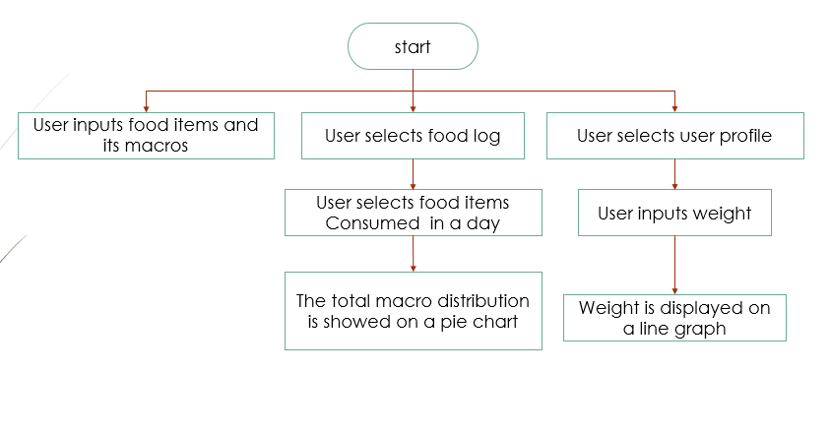

###### implementation

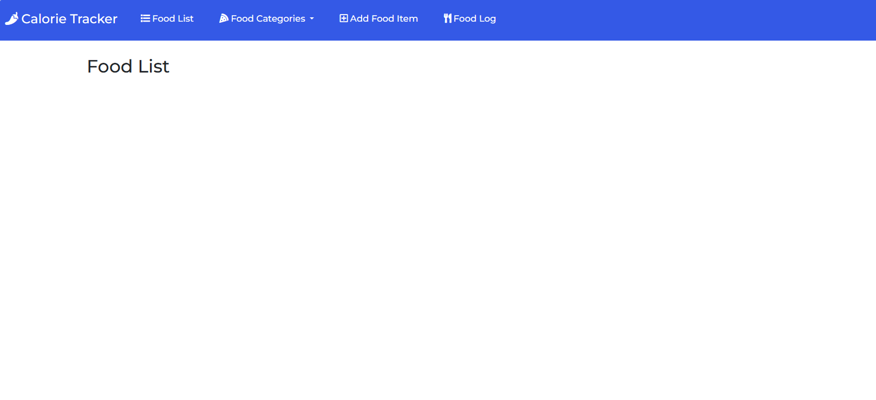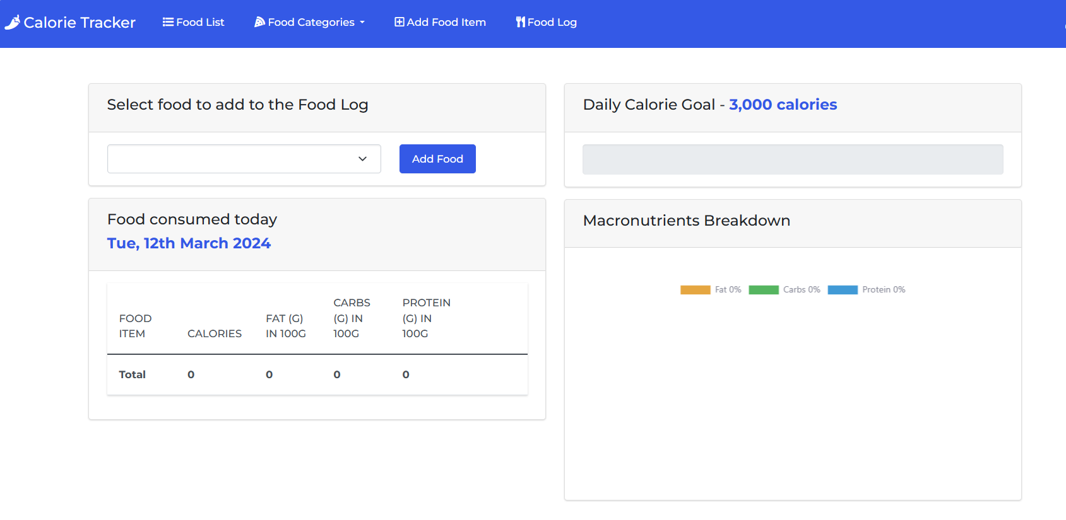

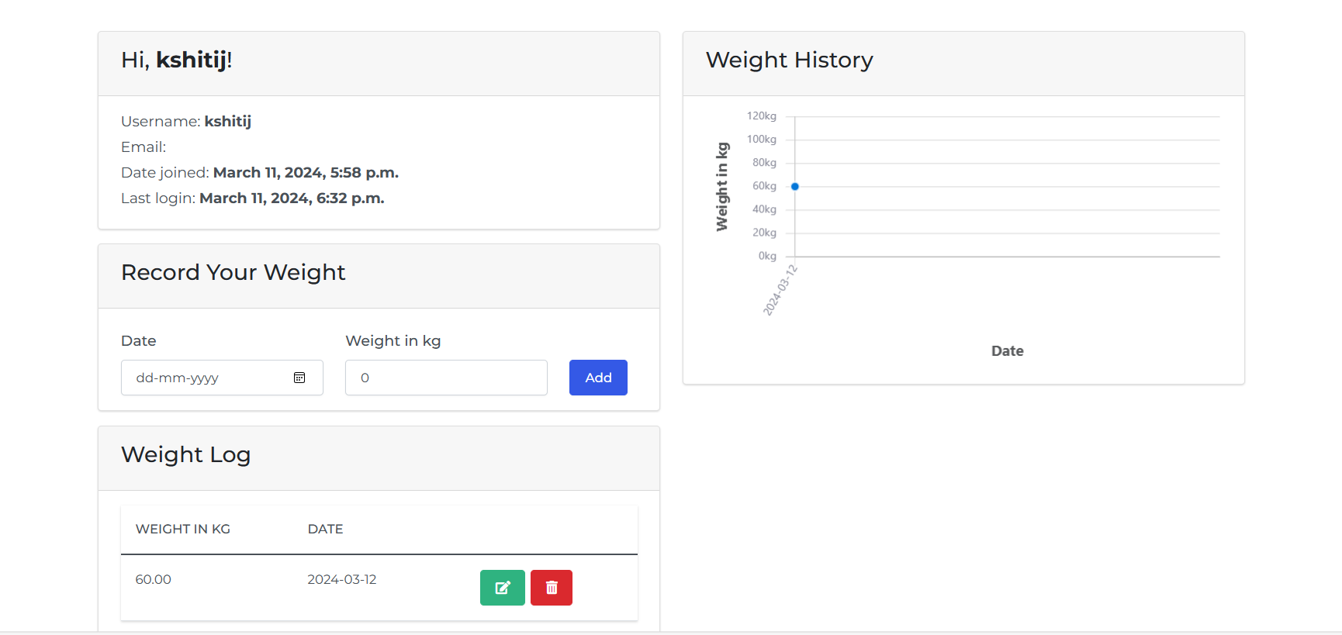

# 

# CHAPTER 6

**Conclusion**

In conclusion, the development of a web-based calorie tracker using Django offers a robust and user-friendly solution for individuals seeking to manage their dietary intake and health goals. By leveraging Django's powerful features such as its built-in admin interface, the calorie tracker can efficiently handle user accounts, store dietary data, and provide insightful analytics.

Through a seamless user experience, individuals can easily log their meals, track calorie intake, set personalized goals, and monitor their progress over time. Additionally, incorporating features like meal suggestions, nutritional information, and interactive charts can enhance user engagement and satisfaction.